Test Case: tc001_SPX_Dev5_Crear_Requisicion_Spot_Tipo_Cobro_CC
Step 1 - Enter username and password and click to button Enter : Credentials Entered
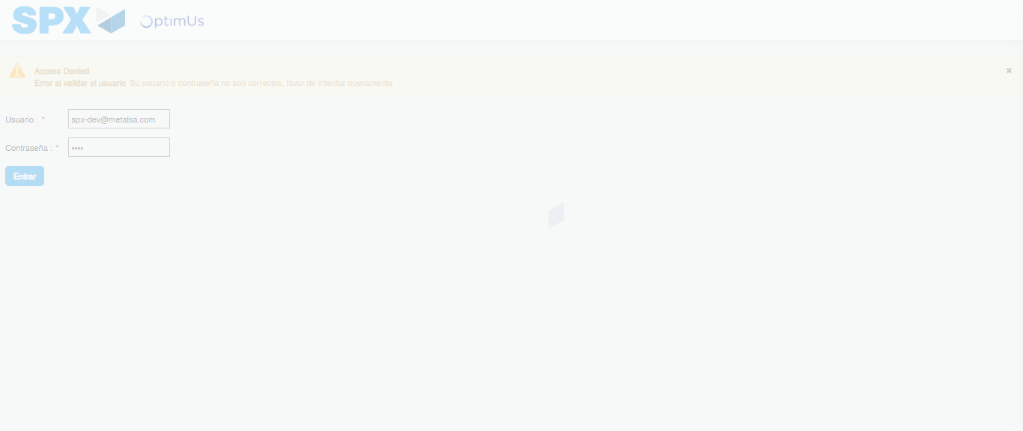Image file-name: QC_Testing-tc001_SPX_Dev5_Crear_Requisicion_Spot_Tipo_Cobro_CC-1789482983907

Step 2 - Select to UEN and Access to Spot Buy Requisitions : UEN Correctly selected and Correct access
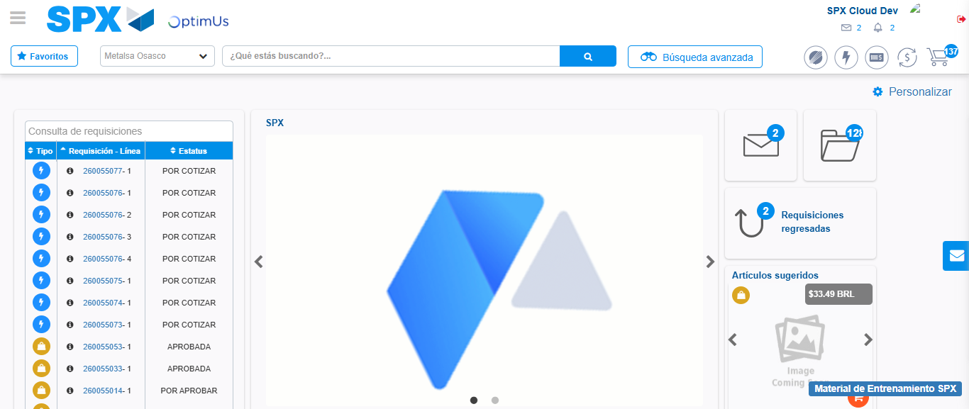Image file-name: QC_Testing-tc001_SPX_Dev5_Crear_Requisicion_Spot_Tipo_Cobro_CC-1789483007005

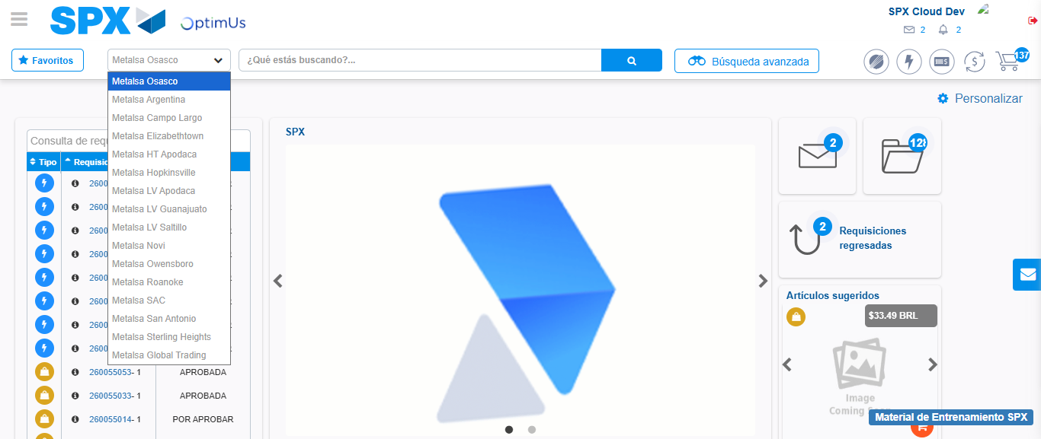Image file-name: QC_Testing-tc001_SPX_Dev5_Crear_Requisicion_Spot_Tipo_Cobro_CC-1789483007631

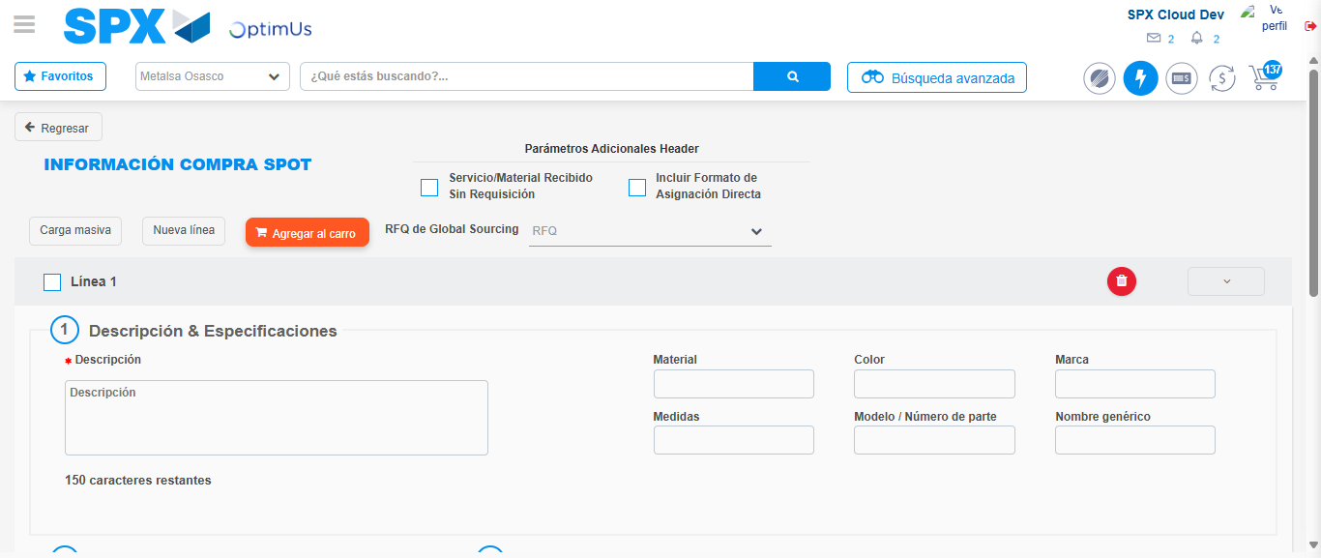Image file-name: QC_Testing-tc001_SPX_Dev5_Crear_Requisicion_Spot_Tipo_Cobro_CC-1789483012361

Step 3 - Data Capture Spot Buy Requisition : Data captured correctly
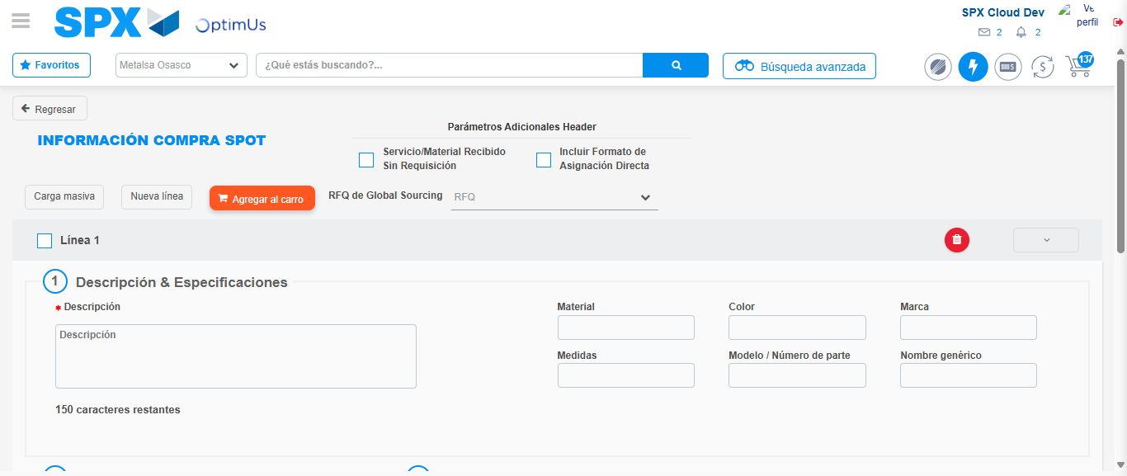Image file-name: QC_Testing-tc001_SPX_Dev5_Crear_Requisicion_Spot_Tipo_Cobro_CC-1789483012668

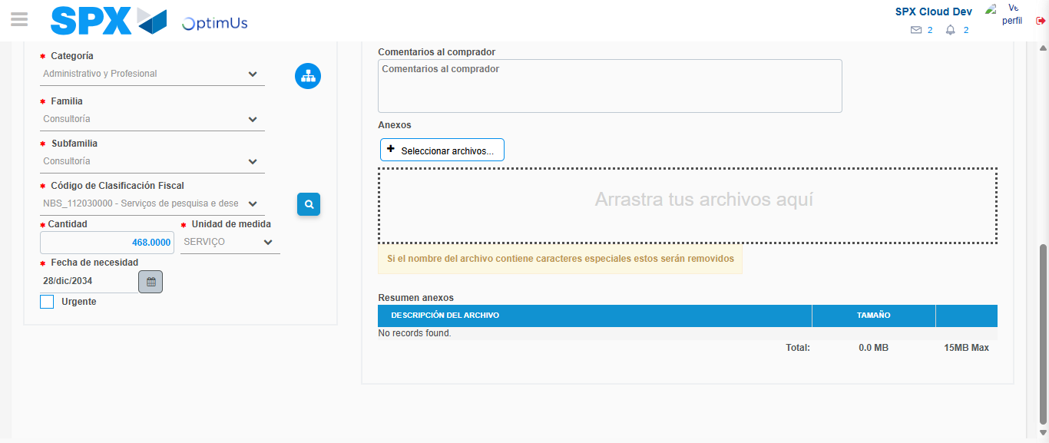Image file-name: QC_Testing-tc001_SPX_Dev5_Crear_Requisicion_Spot_Tipo_Cobro_CC-1789483030521

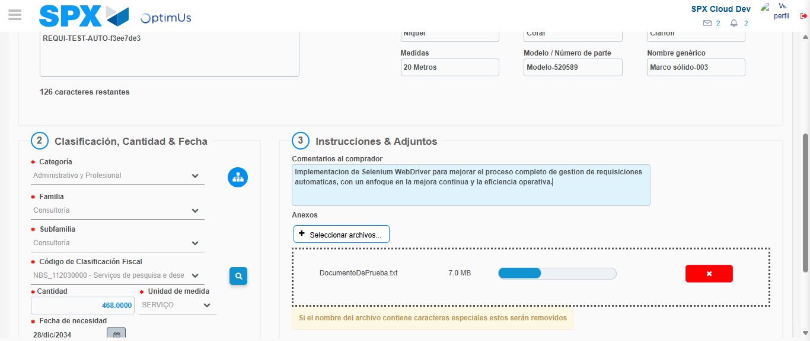Image file-name: QC_Testing-tc001_SPX_Dev5_Crear_Requisicion_Spot_Tipo_Cobro_CC-1789483031351

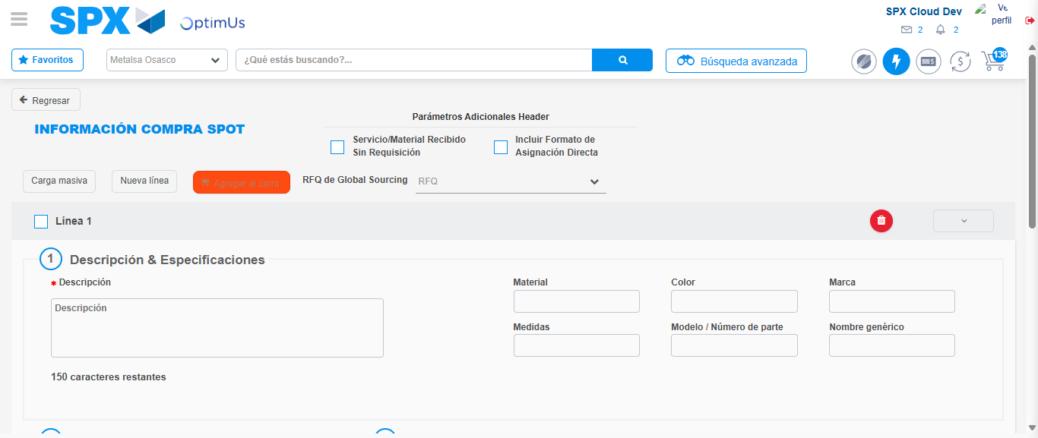Image file-name: QC_Testing-tc001_SPX_Dev5_Crear_Requisicion_Spot_Tipo_Cobro_CC-1789483032838

Step 7 - Return to Main Page SPX : Return to Main Page SPX
Image file-name: QC_Testing-tc001_SPX_Dev5_Crear_Requisicion_Spot_Tipo_Cobro_CC-1789483007005

Image file-name: QC_Testing-tc001_SPX_Dev5_Crear_Requisicion_Spot_Tipo_Cobro_CC-1789483007631

Image file-name: QC_Testing-tc001_SPX_Dev5_Crear_Requisicion_Spot_Tipo_Cobro_CC-1789483012361

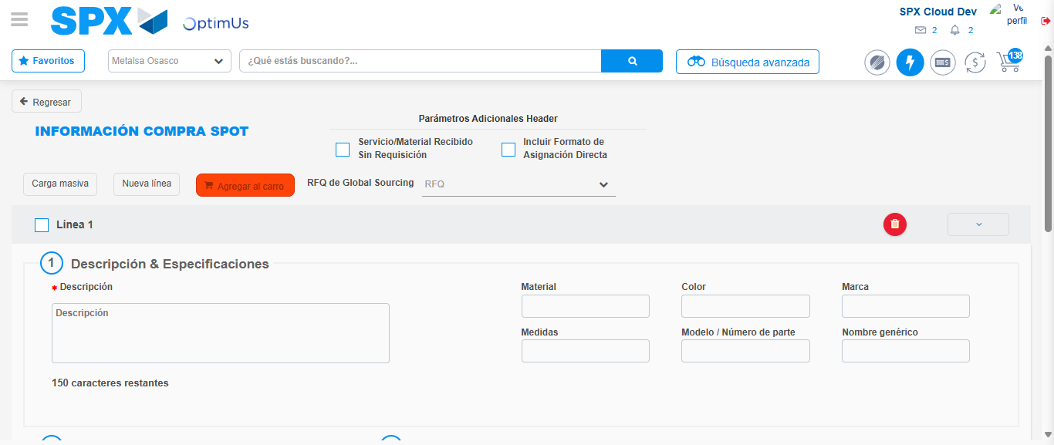Image file-name: QC_Testing-tc001_SPX_Dev5_Crear_Requisicion_Spot_Tipo_Cobro_CC-1789483035067

Image file-name: QC_Testing-tc001_SPX_Dev5_Crear_Requisicion_Spot_Tipo_Cobro_CC-1789483035200

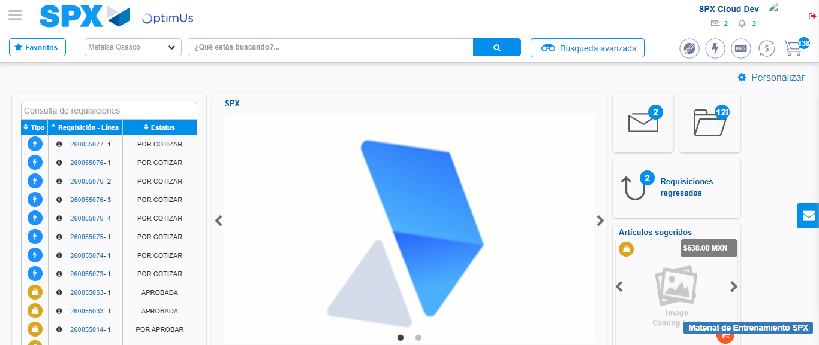Image file-name: QC_Testing-tc001_SPX_Dev5_Crear_Requisicion_Spot_Tipo_Cobro_CC-1789483056211

Step 8 - Log Out : Log Out SPX
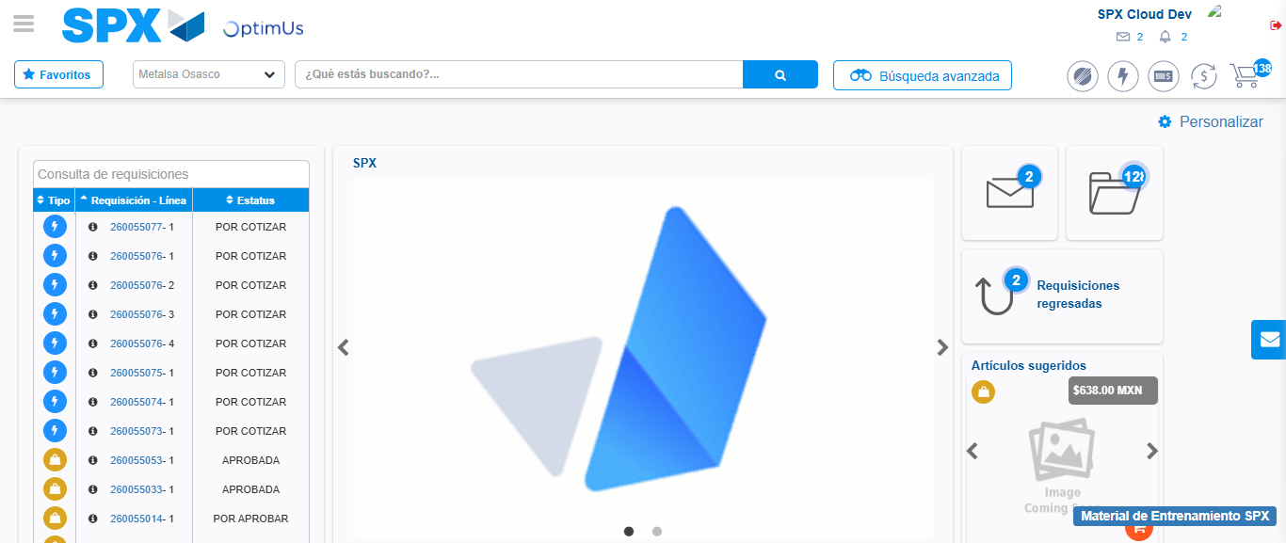Image file-name: QC_Testing-tc001_SPX_Dev5_Crear_Requisicion_Spot_Tipo_Cobro_CC-1789483056478

